System Build Plan — Proof-of-Culture (PoC) Engine
Built on Monad (EVM-compatible)
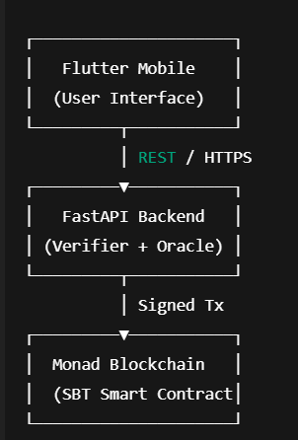
- High-Level System Architecture (Locked)
Trust Model
- Frontend = untrusted
- Backend = verifier/oracle
- Blockchain = source of truth

2. Repository & Folder Structure (Professional)x
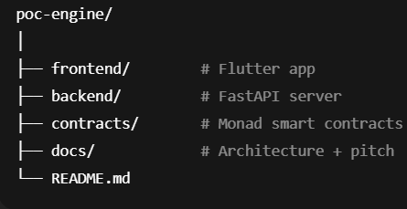
Root Workspace

